Global Humanitarian Funding Gap Dashboard (2015–2026)
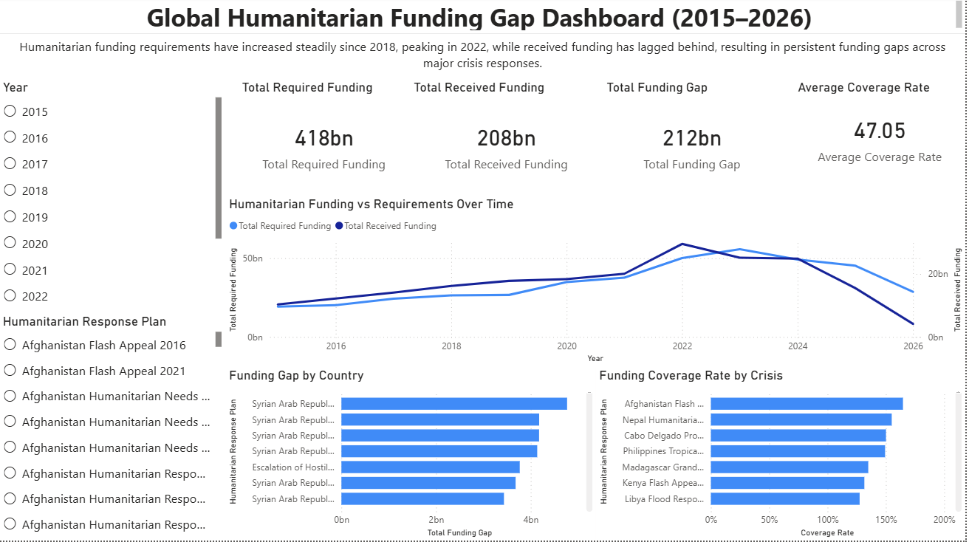
Project Overview
This project analyzes global humanitarian financing trends using publicly available humanitarian funding data. The objective is to examine the relationship between humanitarian funding requirements and the actual funding received for major crisis response plans worldwide.
Using Power BI, an interactive dashboard was developed to explore how funding needs have evolved over time, how effectively crises are funded, and where major funding gaps persist. The dashboard enables users to filter data by year and humanitarian response plan to better understand the dynamics of global humanitarian financing.
The analysis focuses on three key questions:
- How have global humanitarian funding requirements evolved over time?
- To what extent does received funding meet the stated requirements?
- Which crisis responses experience the largest funding gaps and the lowest funding coverage?

Data Source
The analysis uses data derived from humanitarian funding records summarizing annual funding requirements and funding received for humanitarian response plans across multiple countries and crises.
The dataset contains aggregated information including:
- Year
- Humanitarian response plan
- Total funding required
- Total funding received
- Funding gap
- Funding coverage rate
These data points allow for both temporal analysis of funding trends and comparative analysis across crisis responses.

Dashboard Structure
The Power BI dashboard consists of two main analytical pages.
Page 1 – Global Funding Overview
The first page provides a high-level overview of humanitarian funding dynamics.
Key Performance Indicators (KPIs)
Four primary metrics summarize global humanitarian financing:
- Total Required Funding: $418 billion
- Total Received Funding: $208 billion
- Total Funding Gap: $212 billion
- Average Coverage Rate: approximately 47%
These indicators highlight the large gap between global humanitarian needs and available funding.
Funding vs Requirements Over Time
A time-series visualization compares total required funding and total received funding from 2015 to 2026.
This chart allows users to observe how humanitarian needs have evolved and whether funding levels have kept pace.
Funding Gap by Crisis Response
This visualization ranks humanitarian response plans by total funding gap, showing which crises experience the largest shortfalls between required and received funding.
Funding Coverage Rate by Crisis
This chart compares how effectively different crisis responses are funded by showing the percentage of required funding that was actually received.
Together, these visualizations provide insight into both the scale of global humanitarian needs and the uneven distribution of funding across crises.

Page 2 – Funding Distribution and Crisis Comparison
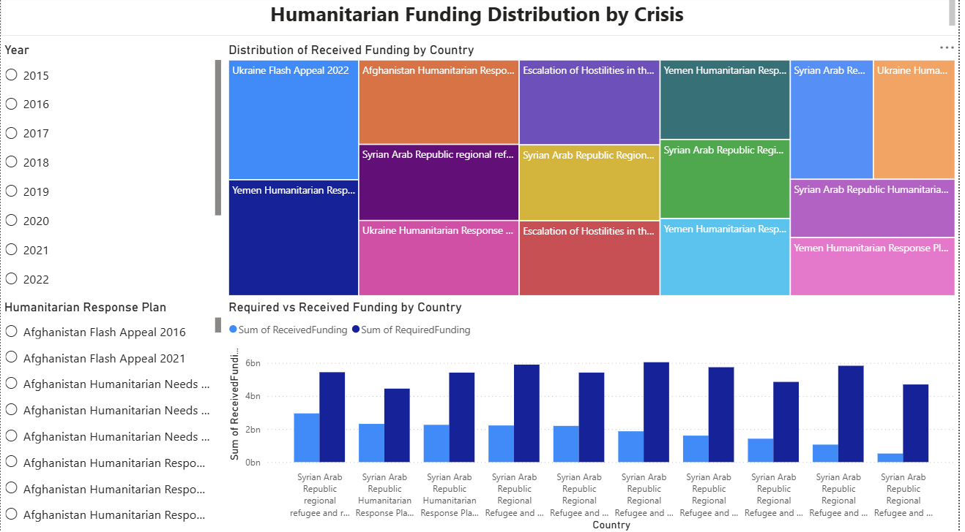
The second page focuses on the distribution of funding across crisis responses.
Distribution of Received Funding
A treemap visualization illustrates how global humanitarian funding is distributed across major crisis response plans. This makes it easier to identify which crises receive the largest shares of funding.
Required vs Received Funding Comparison
A clustered column chart compares required funding with received funding across multiple crisis responses, highlighting structural funding gaps.
This comparison clearly shows that in most cases the amount of funding received remains significantly lower than the required funding.

Key Findings
1. Global humanitarian needs have increased significantly
Humanitarian funding requirements have grown steadily from 2015 to 2022, rising from roughly $20 billion annually to nearly $60 billion at their peak. This growth reflects the increasing scale of global humanitarian challenges, including armed conflicts, climate-related disasters, and displacement crises.

2. Funding has consistently lagged behind requirements
Although total humanitarian funding received has increased over time, it has consistently remained below required funding levels. This persistent gap indicates that humanitarian responses frequently operate under severe financial constraints.

3. A large cumulative funding gap exists
Across the full period analyzed, humanitarian response plans required approximately $418 billion in funding but received only about $208 billion. This results in a cumulative funding gap of roughly $212 billion.
This finding highlights the structural challenge of mobilizing sufficient financial resources to meet global humanitarian needs.

4. Funding requirements peaked around 2022
Both funding requirements and received funding reached their highest levels around 2022. This period coincides with several overlapping global crises, including armed conflicts and climate-related emergencies, which significantly increased humanitarian needs.

5. Funding gaps are concentrated in major, long-running crises
The funding gap analysis shows that some of the largest shortfalls occur in major and prolonged crises, including those related to Syria, Yemen, and other large regional humanitarian response plans.
Long-term crises often accumulate larger funding gaps as humanitarian needs persist while donor funding fluctuates.

6. Funding coverage varies significantly across crises
Funding coverage rates vary widely between humanitarian response plans. Some crises receive funding levels close to or exceeding their requirements, while others remain significantly underfunded.
This variation suggests that global humanitarian funding is unevenly distributed and influenced by factors such as geopolitical attention, donor priorities, and media visibility.

7. A small number of crises receive a large share of total funding
The funding distribution analysis shows that a relatively small number of high-profile crises account for a large share of global humanitarian funding. Major responses such as those related to Ukraine, Syria, Yemen, and Afghanistan receive significant portions of available funding.
This concentration reflects how donor attention often focuses on large or highly visible crises.

Analytical Methods
The analysis used Power BI to create calculated measures and visualizations.
Key calculations included:
Funding Gap
Funding Gap = Required Funding − Received Funding
Coverage Rate
Coverage Rate = Received Funding / Required Funding
These measures allowed the dashboard to evaluate funding effectiveness and identify structural gaps across humanitarian responses.

Tools Used
- Power BI (dashboard design and data visualization)
- Data transformation and calculated measures using DAX
- Humanitarian funding dataset for global crisis response plans

Conclusion
The analysis highlights a persistent mismatch between global humanitarian needs and the financial resources available to address them. While humanitarian funding has increased over time, it has not kept pace with the growing scale of global crises.
The resulting funding gaps place significant constraints on humanitarian operations and underscore the importance of improving global funding coordination, donor engagement, and resource mobilization strategies.

